**Powerflex Arm**

Needs Analysis & Requirement Specifications

**Group # ECE-8**

**Team Members:**

Ryan Whitney

Derek Pridemore

Robert Slapikas

Jared Andersen

Donglin Cai

**Advisors:**

E.C.E. – Dr. Hooker

M.E. – Hollis



**Due Date: 9/25/2015**

|  |  |  |
| --- | --- | --- |
| **Date:** | **Revision:** | **Comments:** |
| 9/18/2015 | 1 | Original Document |
|  |  |  |

Contents

1. Design Team Overview

2. Needs Analysis

2.1 Overview of the Powerflex Arm

Preliminary Project Schedule

Preliminary Project Budject

2.2 Statement of the Problem

Required Capabilities

Desired Capabilities

2.3 Operational Description

3. Requirements Specifications

3.1 Functional Requirements

3.2 Non-functional Requirements

3.3 Constraints

4 Preliminary Test Plan

4.1 Capabilities Test Plan

4.2 Requirements Test Plan

4.3 Constraints Test Plan

5 Deliverables

6 References

# Design Team Overview

**Ryan Whitney** – Team Leader

Manages the team as a whole; develops a plan and timeline for the project, delegates tasks among group member according to their skill sets; finalizes all documents and provides input on other positions where needed.  The team leader is responsible for promoting synergy and increased teamwork.  If a problem arises, the team leader will act in the best interest of the project. He keeps the communication flowing, both between team members and Sponsor.  The team leader takes the lead in organizing, planning, and setting up of meetings.  In addition, he is responsible for keeping a record of all correspondence between the group and ‘minutes’ for the meetings. Finally he gives or facilitatespresentations by individual team members and is responsible for overall project plans and progress

**Robert Slapicas**—Financial Lead, ME Lead

Manages the budget and maintains a record of all credits and debits to project account.  Any product or expenditure requests must be presented to the advisor, whom is then responsible for reviewing and the analysis of equivalent/alternate solutions.  They then relay the information to the team and if the request is granted, order the selection.  A record of these analyses and budget adjustments must be kept. Takes charge of the mechanical design aspects of the project. Keeps line of communication with the lead ECE. He is responsible for knowing details of the design, and presenting the options for each aspect to the team for the decision process.  Keeps all design documentation for record and is responsible for gathering all reports.

**Derek Pridemore—**Web designer, Co-lead ECE

He is responsible of the EE, IE, or CE design part in support of the project.  He maintains line of communication with the lead ME. He keeps all design documentation for record. Designs, organizes, and implements the project web page.

**Jared Andersen**—Co-lead ECE

He is responsible of the EE, IE, or CE design part in support of the project.  He maintains line of communication with the lead ME. He keeps all design documentation for record.

**Donglin Cai—**Co-lead ECE

He is responsible of the EE, IE, or CE design part in support of the project.  He maintains line of communication with the lead ME. He keeps all design documentation for record.

# Needs Analysis

## Overview of the Powerflex Arm

The power arm is a device that fits over the arms of the user and uses electromechanical actuators to add to their strength. It either contains a strong exoskeleton to help bear loads or it uses straps to attach to the user’s body and increases the torque generated by the user's skeleton.

|  |  |  |  |  |  |  |
| --- | --- | --- | --- | --- | --- | --- |
|  | price | safety | power | lifespan | geometric mean | normalized weight |
| price | 1 | 0.2 | 0.5 | 0.33333 | 0.4273 | 0.0779 |
| safety | 5 | 1 | 5 | 5 | 3.3437 | 0.6095 |
| power | 2 | 0.2 | 1 | 0.5 | 0.6687 | 0.1219 |
| lifespan | 3.000003 | 0.2 | 2 | 1 | 1.0466 | 0.1908 |

### Preliminary Project Schedule

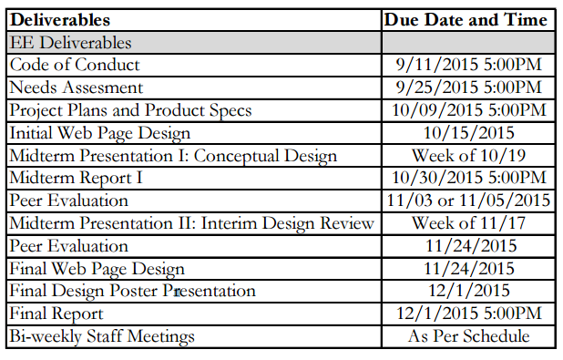

### Preliminary Project Budget

$1,400

## Statement of the Problem

People sometimes need assistance with moving their arms under load. Current strength-assistance orthotics are bulky, expensive, or not user friendly.

### Required Capabilities

The primary objective of this project is to come up with a strength-assisting orthotic that is minimally bulky and expensive.

### Desired Capabilities

This project should ideally be user friendly: easy to modify, safe, ergonomic, and dependable under a wide range of use cases. It should be light, strong, and long lasting.

## Operational Description

The orthotic will start off being controlled by an onboard flex/relax switch and will later have an onboard system for determining with to do so in an autonomous fashion.

|  |  |  |  |  |  |  |  |  |  |  |
| --- | --- | --- | --- | --- | --- | --- | --- | --- | --- | --- |
| need | weight | fits inside budget | ease of use | simplicity | modularity | safety | dependability | ergonomics | lifts minimum weight | lifespan |
| price | 0.0779 | x |  | x | x | x | x | x | x | x |
| safety | 0.6095 |  |  |  | x | x | x | x | x | x |
| power | 0.1219 | x |  |  |  | x | x |  | x | x |
| lifespan | 0.1908 | x |  |  |  | x | x |  |  |  |

# Requirements Specifications

## Functional Requirements

* Increase strength by a non-marginal amount
* A mobility close to 150 degrees - minimal loss in natural movement (180 degrees)

## Non-functional Requirements

* Ergonomic

## Constraints

* Project Budget can not exced $1,400.
* System must be structurally sound.
* System must supply at least some lifting force.

# 4 Preliminary Test Plan

## 4.1 Capabilities Test Plan

First we will test the artificial muscles as a stand alone, to analyze strength and speed of of the muscle to determine if it will achieve the desired results. Then we will create a simulation to model the muscle to test and observe strain and lifespan of the material.

## 4.2 Requirements Test Plan

After the capabilities of existing technologies have been determined, their ability to be used in this solution will be calculated and weighted against the requirements to determine whether or not they will be implemented.

# 5 Deliverables

1. A working prototype by the end of the semester.
2. Working website by the end of the semester.
3. Working orthotic by the end of the year.
4. Working simulations of the orthotic system by the end of the year.

# 6 References